Chapter 3, Solution 32

Obtain the node voltages v₁, v₂, and v₃ in the circuit of Fig. 3.81.

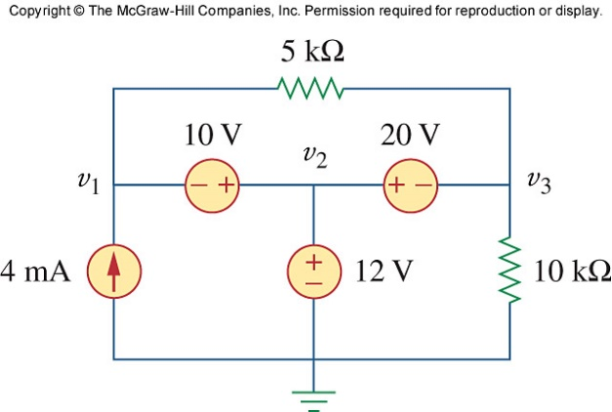
Figure 3.81
For Prob. 3.32.

Solution

v₃

(b)

v₁

v₂

5 kΩ

(a)

4 mA

10 kΩ
+
v₁
–

+
v₃
–

–
+

12 V
+ –

20 V
– +

loop 2

loop 1

10 V

We have a supernode as shown in figure (a). It is evident that v₂ = 12 V, Applying KVL to loops 1and 2 in figure (b), we obtain,

-v₁ – 10 + 12 = 0 or v₁ = 2 and -12 + 20 + v₃ = 0 or v₃ = -8 V

Thus, v₁ = 2 V, v₂ = 12 V, v₃ = –8V.

